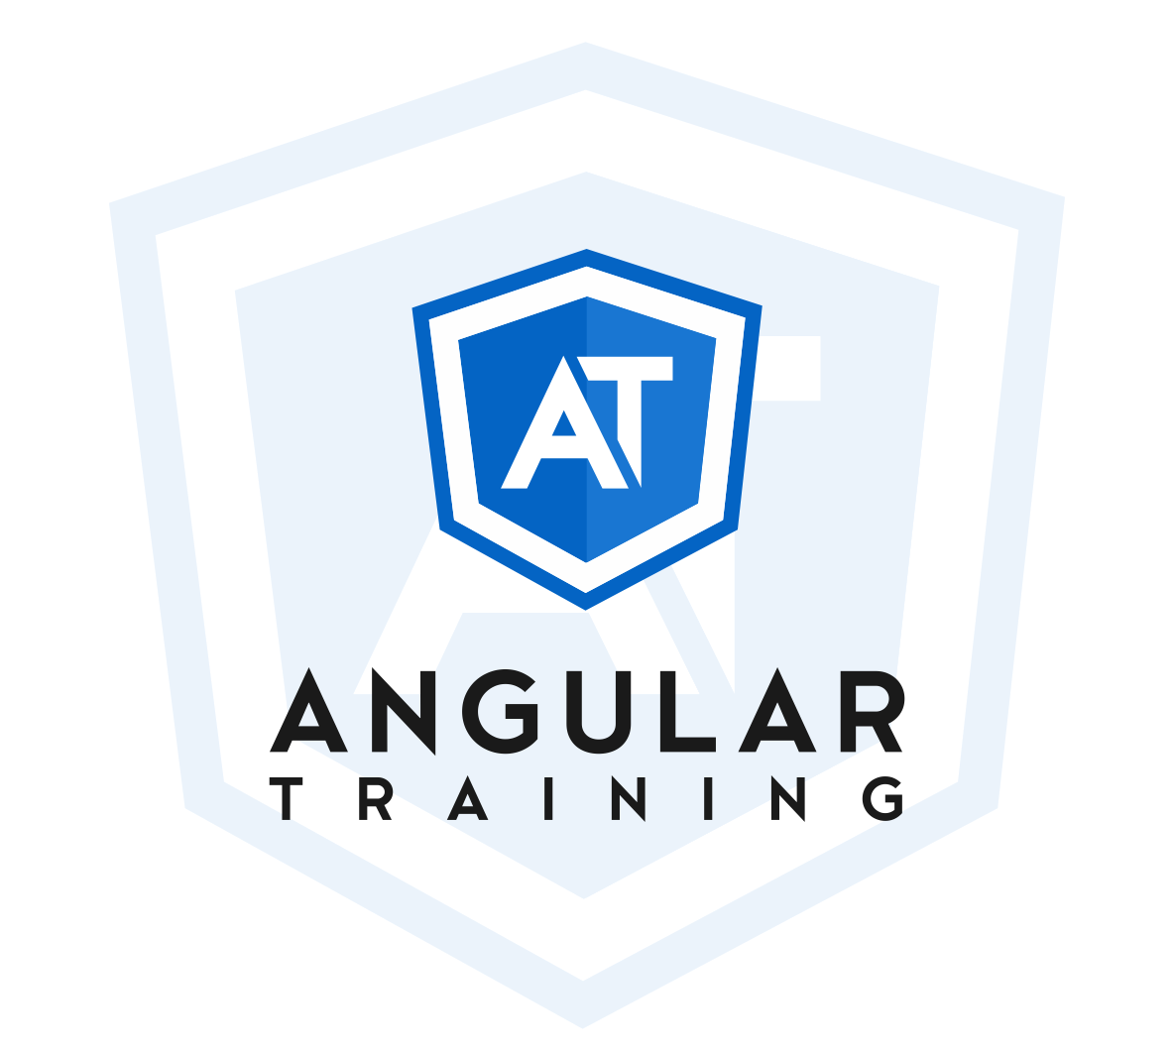

**Angular**

**Level 2 Certification  
mini-project**

**angulartraining.com**

This document is online at

<https://bit.ly/at-cert-l2-quiz>

# **GOAL: Build a small quiz maker application that creates a 5-question quiz based on a trivia API**

For this project, we recommend using the online IDE StackBlitz and creating a new Angular project: <https://stackblitz.com/>. This will make it easy to submit your code as a single link once you’re done with the project.

If you’re unfamiliar with StackBlitz and want to use your own IDE and tools, we recommend using GitHub to host the project and publish a built version of your code using [GitHub pages](https://pages.github.com/).

To submit your work, you’ll need to provide either the link to your StackBlitz project or a link to a Git repository that contains your code, along with a URL to test the app in a browser.

**Important rules and notes - please read carefully:**

You have to **write the code yourself**. Submitting code already submitted by a friend or colleague is not allowed and will result in disqualification from the certification exam.

Code **quality and best practices matter**. Please do not use the **any** type in Typescript or have a single component in your application. Your code **MUST** use proper types for all variables, methods, parameters, etc. Failure to do so will automatically disqualify your submission.

It should go without saying that **your application will be disqualified and your certification exam marked as failed if the application has bugs, doesn’t implement all of the features, or doesn’t follow the instructions of this document.**  
  
**Finally**, once your application is working and implemented following best practices (using types and proper component architecture), **submit your work** by going to <https://angulartraining.com/certification/level2-step2.html>

If you have any doubts or questions, send an email to Alain at [contact@angulartraining.com](mailto:contact@angulartraining.com)

**STEP #1 - Implement the ability to select a trivia category and difficulty level**

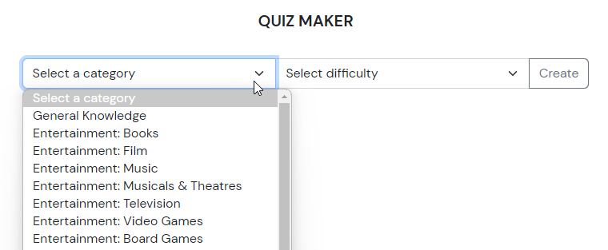

* The API used to get the list of categories can be found at: <https://opentdb.com/api_category.php>
* The 3 difficulty levels are: Easy, medium, hard.
* Note that styling is not that important for this project, and the layout of your application can be different as long as the application works properly. This is an Angular certification, not a CSS or HTML certification.
* The category dropdown should have an HTML attribute ID equal to **categorySelect,** the difficulty dropdown should have an ID equal to **difficultySelect,** and the button should have an ID equal to **createBtn**

**STEP #2 - Display a 5-question quiz based on the selected category/difficulty**

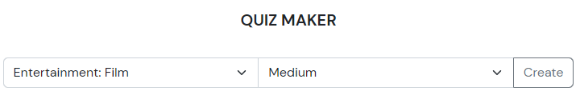

* Use the [Open Trivia Database API](https://opentdb.com/) to get the data. For instance, this request will give you 5 questions for easy film trivia:   
  <https://opentdb.com/api.php?amount=5&category=11&difficulty=easy&type=multiple>
* Each possible answer should be a clickable button that gets highlighted and remains as such when clicked. When all questions are answered, a submit button should become visible.

**STEP #3 - Display the results of the quiz with the right/wrong answers**

**RESULTS**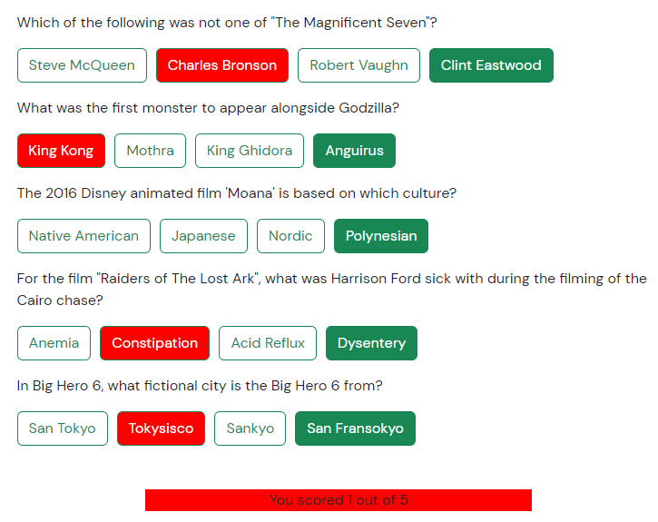



* Once the user submits their quiz, navigate to a different component (using the Angular router) that highlights the user’s answers in green color when it is a correct answer, or red color when it is the wrong answer. The correct answer is always displayed in green.
* Display the final score at the bottom with the following color scale:
  + Red color if 0 or 1 correct answer, Yellow color if 2 or 3 correct answers, Green color if 4 or 5 correct answers
* Add a button at the bottom of the page that redirects to the new quiz creation screen.